edi3 Model Interchange 1.0 Specification

Status
raw
raw

Licence
All material published on edi3.org including all parts of this specification are the intellectual property of the UN as per the UN/CEFACT IPR Policy.
This Specification is free software; you can redistribute it and/or modify it under the terms of the GNU General Public License as published by the Free Software Foundation; either version 3 of the License, or (at your option) any later version. See http://www.gnu.org/licenses.

Change Process
This document is governed by the 2/COSS (COSS).

Language
The key words “MUST”, “MUST NOT”, “REQUIRED”, “SHALL”, “SHALL NOT”, “SHOULD”, “SHOULD NOT”, “RECOMMENDED”, “MAY”, and “OPTIONAL” in this document are to be interpreted as described in RFC 2119.

Introduction
This specification provides a standard JSON structure/schema for the representation of semantic library content and API models. This is used to
- import library content into any conformant modelling tool, and to
- interchange API models between conformant modelling tools.
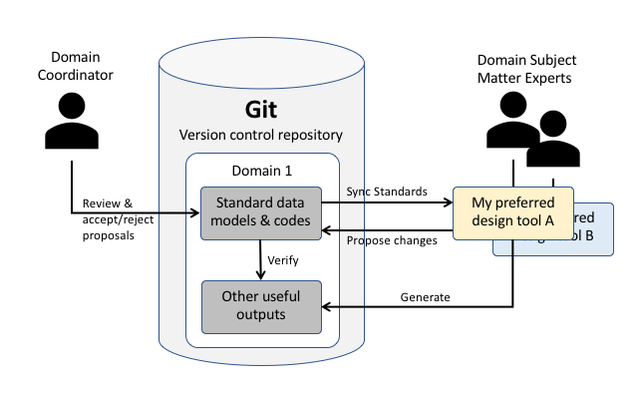
use case
This specification will have achieved its purpose when at least two different modelling tools (UML based or otherwise) can successfully interchange any of the three model types.

Metamodel Overview
A DSL (domain specific language) approach is preferred here because it will be simpler and more stable than XMI (interchange standard for UML tools) and will allow non-UML based tools to participate equally in the market.
The interchange specification is broken into three parts, each with a dedicated metamodel and each representing models that can be interchanged independently.
- The domain model is essentially the “towm plan” for all UN/CEFACT API resources.
- The resource model details the state lifecycle and information model of a specific API resource.
- the CodeList model represents code list schemes and the flat or hierarchical set of code values.
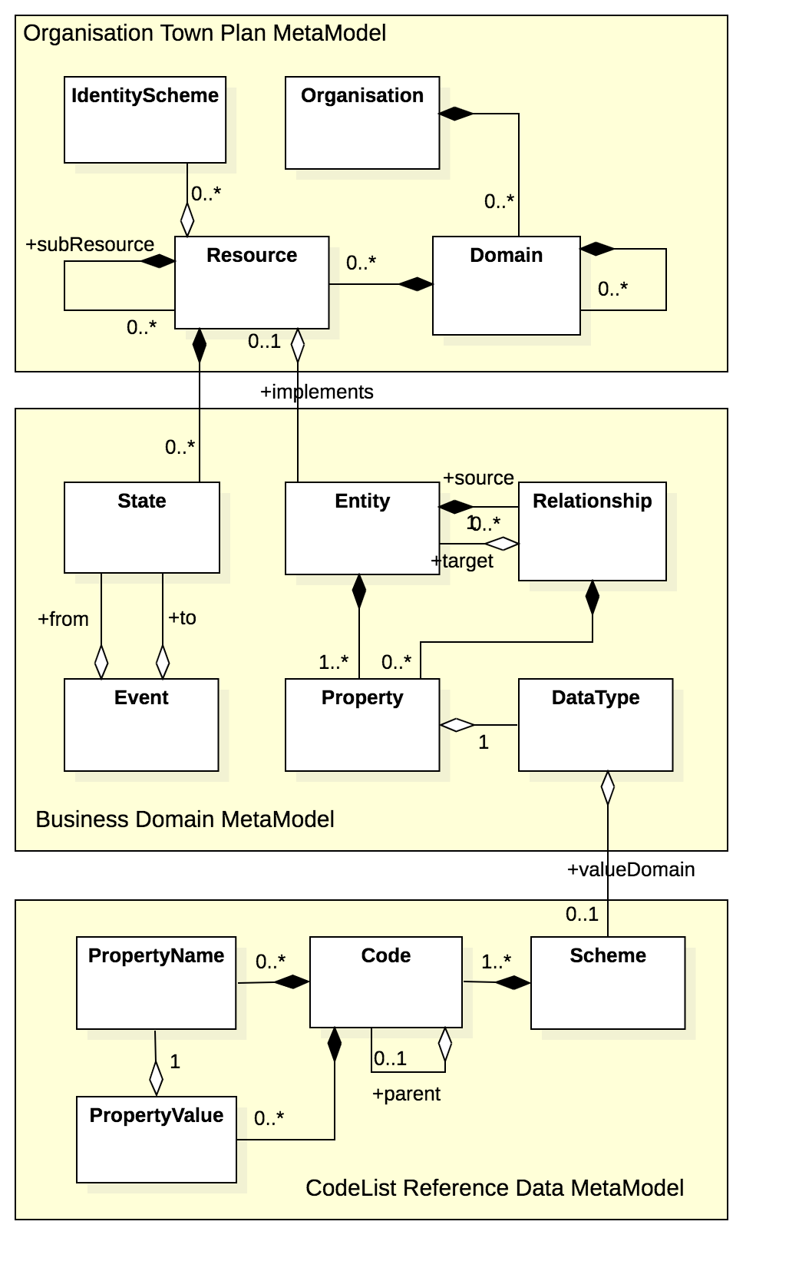
metamodel

Town Plan Model Specification

Logical Model
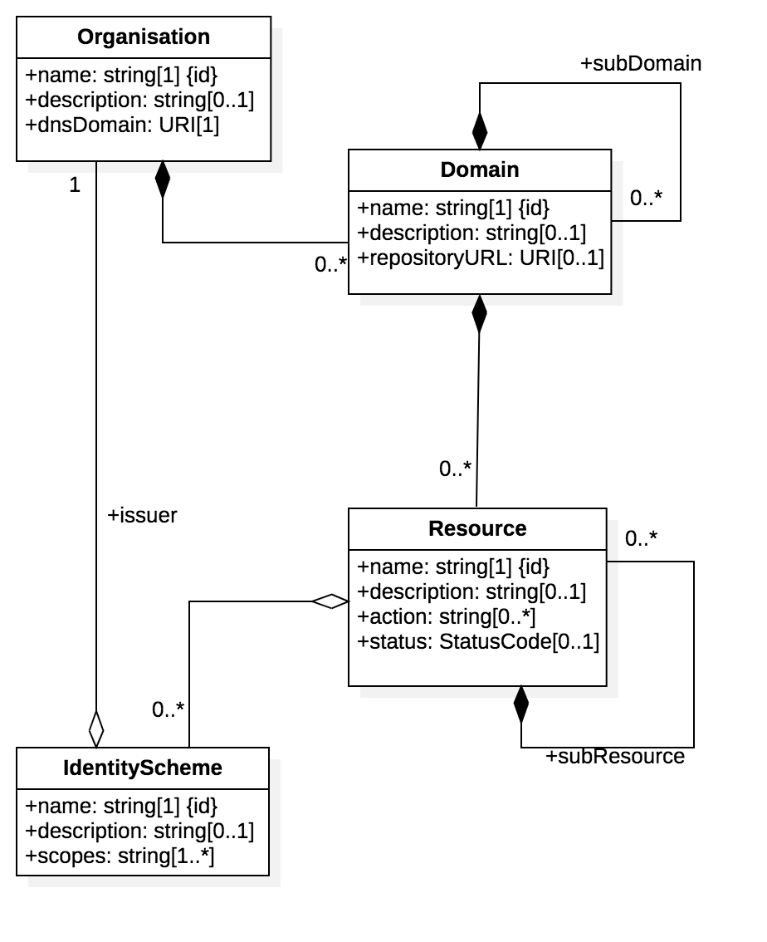
town plan

JSON Schema
town plan schema

Sample
coming soon

Domain Model Interchange Specification

Logical Model
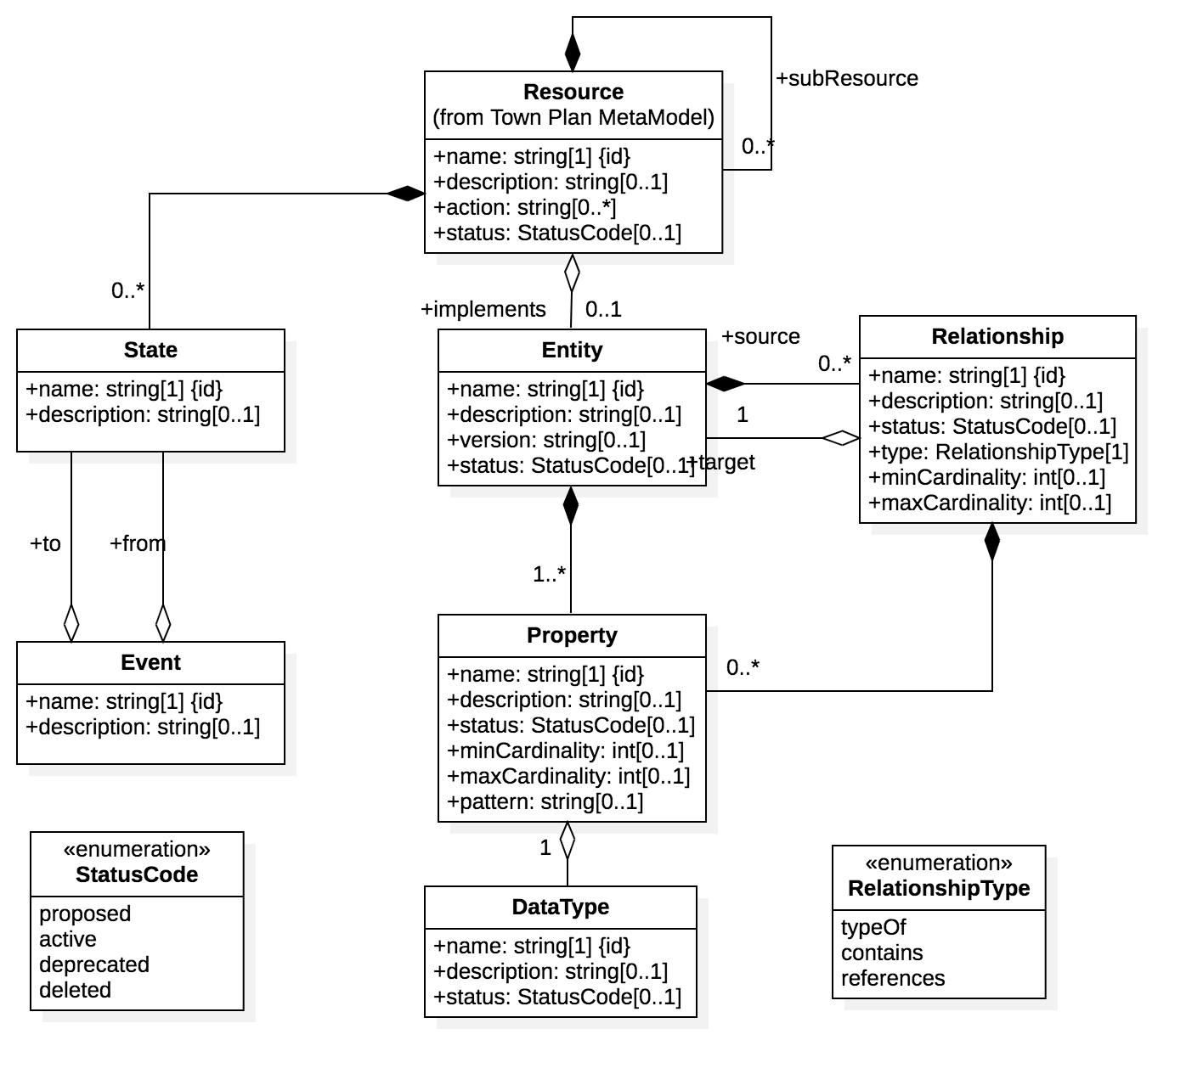
domain model

JSON Schema
town plan schema

Sample
coming soon

CodeList Interchange Specification

Logical Model
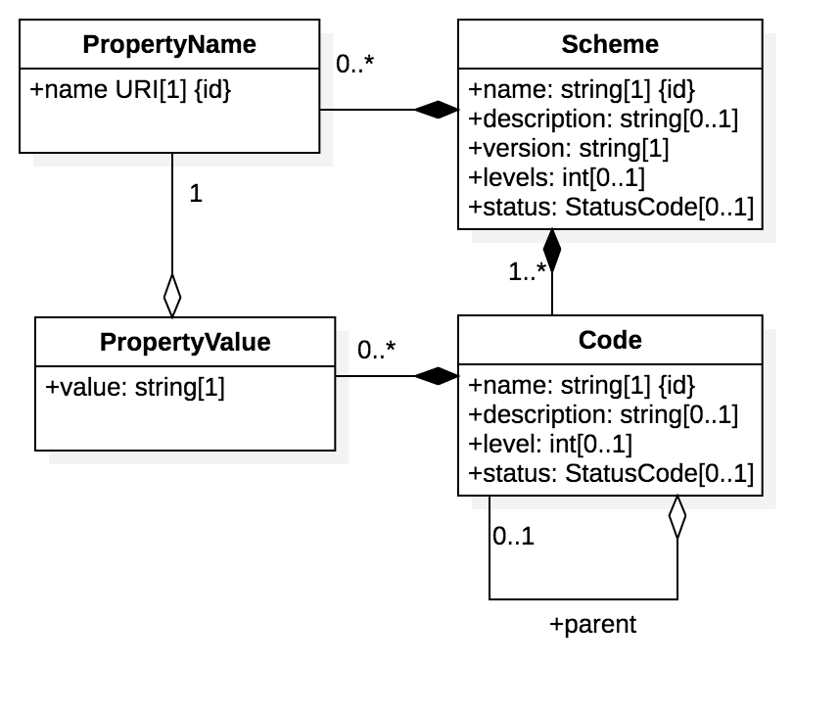
codes model

JSON Schema
codes schema

Sample
coming soon

